## **Quality Control (QC) Process**

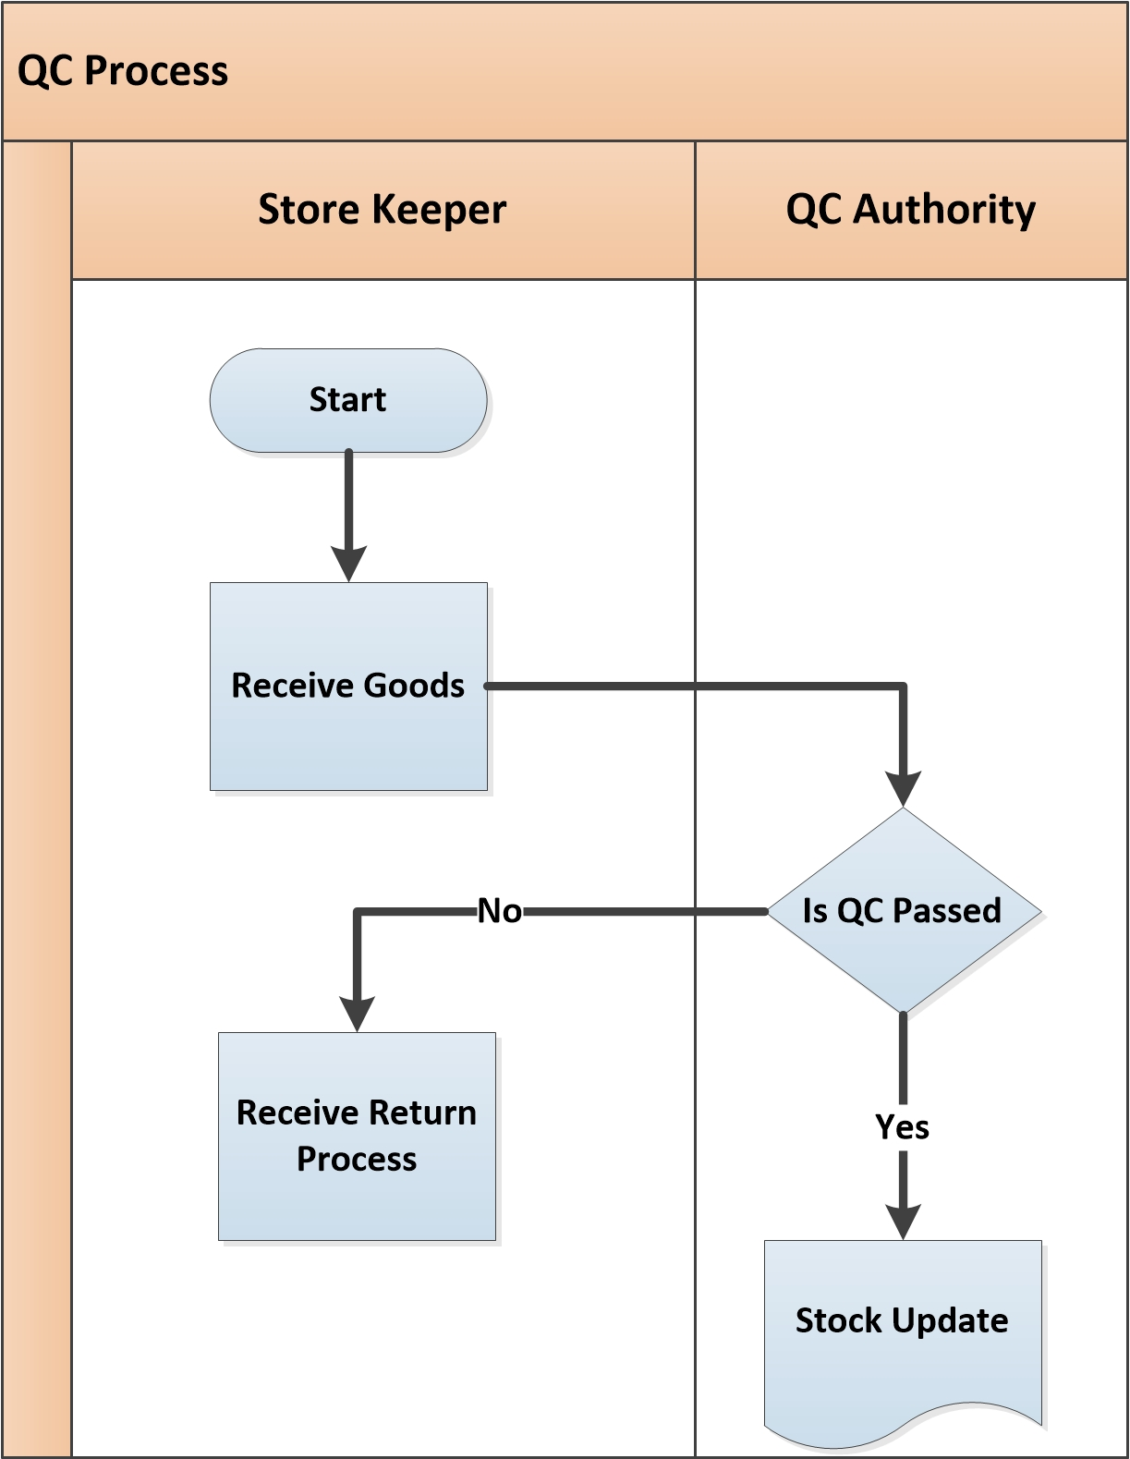

**Fig:** Quality Control (QC) Process

**QC Process Description**

* Gate Security checks the item and pass it to storekeeper.
* Store keeper receives goods which was sent by supplier.
* Store keeper confirms his acceptance as per order and sends all goods to QC authority for proper quality control.
* QC Authority checks the quality and quantity of goods as per Order. According to QC result they take necessary decision-
  + **QC Passed:**
    - If goods are in good quality and exact quantity then QC accept the goods and update the stock of the goods.
  + **QC Failed:**
    - If goods are not acceptable and not in exact quantity/quality, QC authority returns the rejected goods to Store Keeper for receive return to Supplier

Store Keeper receives all rejected goods which were sent by QC authority and sends the goods back to Supplier for further action.